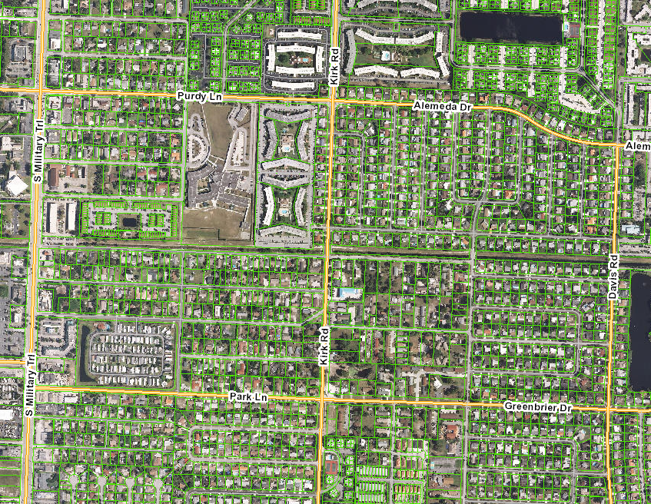
Project: #040 16-9709P.03
Project: L-9 from 775ft west of Kirk Rd to Gulfstream Rd
Reach: 0.39 mi

